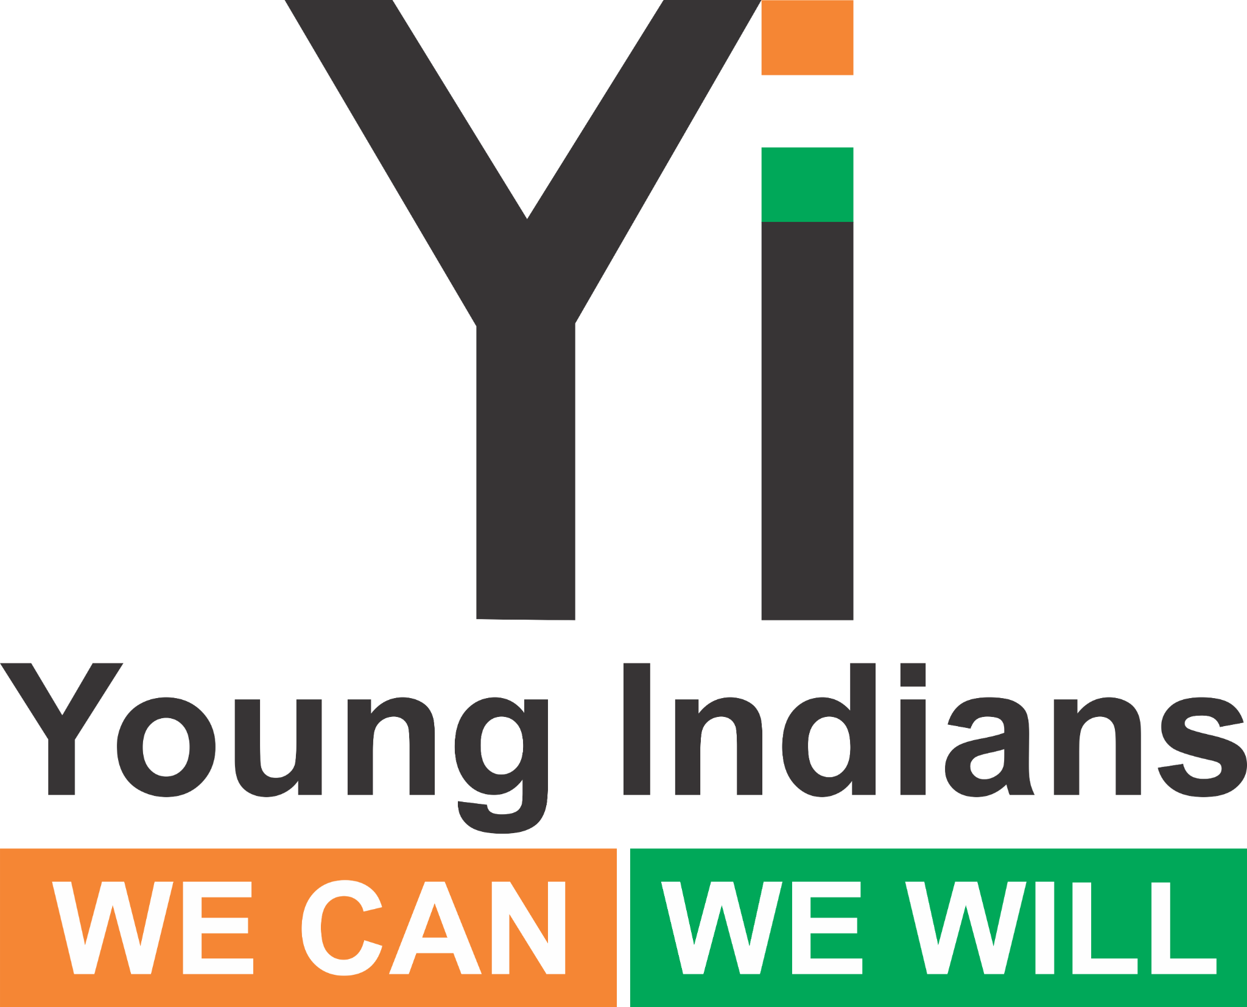 | Chapter - Action Checklist

□ Fix date/time/venue & moderator/rapporteur
□ Invite participants (youth, experts, PwDs, NGOs)
□ Add Fireflies AI
□ Prepare slides/video; print handouts
□ Run 2-hour session (Health then Accessibility)
□ Post photos & quotes (#YiHealth2025 #EnableAccess2025)
□ Send Fireflies link + 1-page report within 24 hrs (deadline: 28 Sept)

