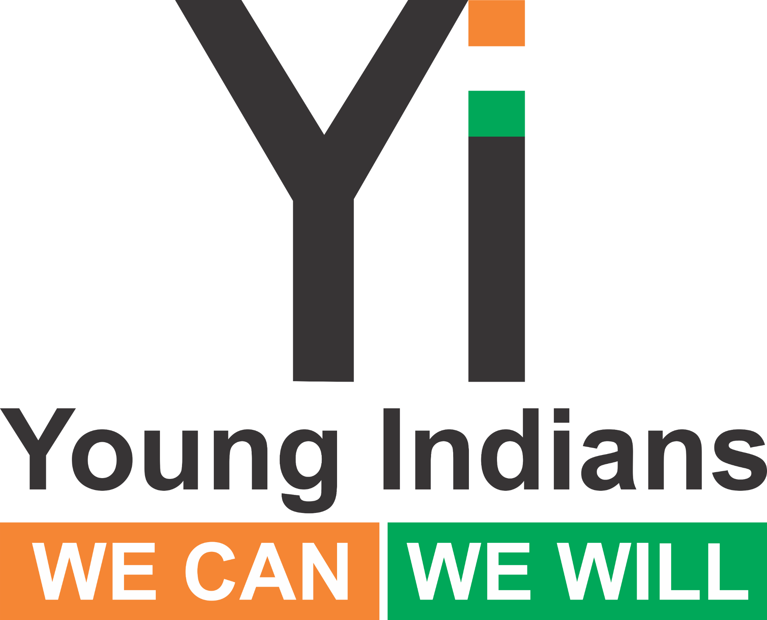 | Strong Minds, Open Doors — Accessibility Round Table  Chapter Prompt Bank & Handout Kit

Why this programme (and why now)
• Accessibility equals dignity, safety, and participation—for everyone.
• Universal design benefits all users (parents with strollers, seniors, people with temporary injuries), not only PwDs.
• The RPwD Act and national standards expect barrier‑free public services; local gaps persist in spaces, transport, and digital access.
• These Round Tables convert local insight into practical fixes and a national policy voice at the Yi Summit.
How chapters should use this kit
1) Pick **ONE or TWO** topics (max) that fit your local context.
2) From the prompt bank, choose 6–10 prompts that will work best for your room.
3) Print the **Participant Handout Seeds** for only those topics you’ve chosen.
4) Timebox: 45 minutes total for Accessibility (see mini‑agendas). Keep notes visible on a board.
5) Close with **two concrete commitments** (who/what/when) and capture them in your report.
6) Add **Fireflies AI (fred@fireflies.ai)** to record + minute. Forward link/PDF within 24 hours.
7) Optional: Do a quick photo‑audit of one nearby facility to visualise barriers and wins.
Mini‑agendas (pick one)
30 min | Welcome 3’ • One topic 20’ • Commitments 5’ • Close 2’
45 min | Welcome 5’ • One topic 25’ • Second topic 10’ • Commitments 5’
60 min | Welcome 5’ • Two topics @20’ each • Commitments 10’ • Close 5’
Inclusion, safety & respectful facilitation
• Ensure step‑free entry, seating with space for wheelchairs, clear signage, and a working mic.
• Use person‑preferred language; avoid tokenism—invite PwDs as co‑facilitators/speakers.
• Avoid questions that force personal disclosure; obtain consent before photos.
• Provide large‑print/contrast materials; arrange interpreters/captions where possible.

Topic A — Physical Access: More than Ramps
• What are the biggest physical barriers in your area (doors, corridors, stairs, signage, toilets, parking)?
• Which public routes are missing continuous step‑free paths (footpaths, crossings, last‑mile to transit)?
• How accessible are transit nodes (bus/metro stops, ticket counters, platforms, lifts, announcements)?
• What low‑cost retrofits matter most now (portable ramps, handrails, lever handles, contrasting edges)?
• How can we prioritise ‘highest impact’ spaces (toilets, entrances, service counters, classrooms)?
• How will we maintain accessibility after the ribbon‑cutting (cleaning, repairs, checks, budget owner)?
• Who can certify or audit (third‑party, local architects, disability orgs)? How often?
• What procurement standards ensure we don’t buy inaccessible furniture/equipment again?
• How can we crowd‑map barriers and wins (simple map, photo pins, QR reporting)?
• Plan an ‘Accessible Event Checklist’ for your next Yi meeting (venue, stage, seating, signage).
• How do we include persons with multiple disabilities (visual, hearing, mobility, neurodiversity) in design?

Topic B — Inclusive Education & Workplaces
• What reasonable accommodations should be standard (note‑takers, extra time, flexible seating, assistive tech)?
• How inclusive are admissions/hiring processes (forms, interviews, assessments, building access)?
• What policies help: flexible schedules, hybrid/remote options, internship pathways, ergonomic adjustments?
• How do we make digital documents, slides, and LMS tools accessible (alt text, captions, contrast, headings)?
• What training do teachers/managers need on inclusive practices and bias awareness?
• How do grievance redressal and confidentiality work today? What needs to improve?
• What buddy/mentorship systems help new students/employees settle confidently?
• How can clubs, sports, and cultural events be inclusive by design?
• How do we measure inclusion (participation rates, accommodation turnaround time, satisfaction surveys)?
• What partnerships (NGOs, skilling orgs, CSR) can expand opportunities for PwDs?
• Create one model ‘Accommodation Plan’ template that your chapter can share locally.
• What would a ‘no barriers onboarding’ journey look like at your school/company?

Topic C — Accessible Healthcare & Services
• How accessible are local clinics/hospitals (entrances, reception heights, signage, waiting areas, toilets)?
• What assists OPD flow—token systems, priority queues, seating with space for mobility aids?
• How do we ensure informed consent and privacy for PwDs (communication aids, sign language, caregivers)?
• Are emergency exits, alarms, and evacuation plans accessible for all?
• How can telemedicine and hospital apps meet accessibility standards (captions, screen‑reader support, simple UX)?
• Are ambulance and patient transport services accessible? What’s missing?
• Do staff receive disability etiquette and basic assistive training? What would a 2‑hour module include?
• What financing/insurance barriers exist—and how can social workers/helpdesks bridge them?
• How can pharmacies and labs improve (counter height, tactile cues, queue systems, clear lab reports)?
• How can we include caregivers without compromising the patient’s autonomy and dignity?
• What community outreach (camps, home visits) can reduce travel and navigation burdens?

Topic D — Attitudes & Awareness: Changing the Lens
• What subtle biases or micro‑barriers show up daily (tone, assumptions, ‘helping’ without consent)?
• Which words/phrases should we retire, and what respectful alternatives can we adopt?
• How do we embrace ‘nothing about us without us’ in our chapter planning?
• What stories or role models shift mindsets in your community? How do we platform them?
• How do we respond if someone resists accessibility (‘too costly’, ‘too few people’)?
• What allyship behaviors can everyone practice this month (offer choices, ask before helping, describe surroundings)?
• How do we ensure intersectional inclusion (gender, rural, income, language)?
• Create an inclusive communications checklist (plain language, captions, alt text, readable fonts).
• How will we track culture change (stories collected, participation diversity, follow‑up surveys)?
• Draft an ‘Open Doors Pledge’ for your chapter/event and invite sign‑ups.
• Plan one ‘Accessibility Walkthrough’ with PwDs co‑leading—then share learnings publicly.

Participant Handout Seeds (print only for chosen topics)

Seed — Physical Access: More than Ramps
• Why we’re here: make everyday paths and places usable for everyone.
• Prompts: quick audits; high‑impact low‑cost retrofits; 30‑day access sprint; event checklist.
Notes / Ideas: ________________________________ ________________________________
Commitment (one action before the Summit): _____________________________________

Seed — Inclusive Education & Workplaces
• Why we’re here: ensure learning and livelihoods are barrier‑free.
• Prompts: accommodations; accessible docs; buddy systems; hiring/onboarding journeys.
Notes / Ideas: ________________________________ ________________________________
Commitment (one action before the Summit): _____________________________________

Seed — Accessible Healthcare & Services
• Why we’re here: dignity and safety in care settings.
• Prompts: OPD flow; signage; app/telemedicine accessibility; staff training; 30‑day clinic fixes.
Notes / Ideas: ________________________________ ________________________________
Commitment (one action before the Summit): _____________________________________

Seed — Attitudes & Awareness: Changing the Lens
• Why we’re here: shift culture, not blame.
• Prompts: language; allyship; mini‑campaign; ‘Open Doors Pledge’; accessibility walkthrough.
Notes / Ideas: ________________________________ ________________________________
Commitment (one action before the Summit): _____________________________________

What to submit after your session
• Top 5 insights from the chosen topic(s)
• Two concrete commitments (who/what/when)
• Optional: before/after photo of one small fix
• Fireflies AI transcript/minutes link + 1–2 photos
• Use the national reporting template by **28 Sept**

Thank you for powering Strong Minds, Open Doors. Your local actions inform the Yi National Health & Accessibility Summit.

