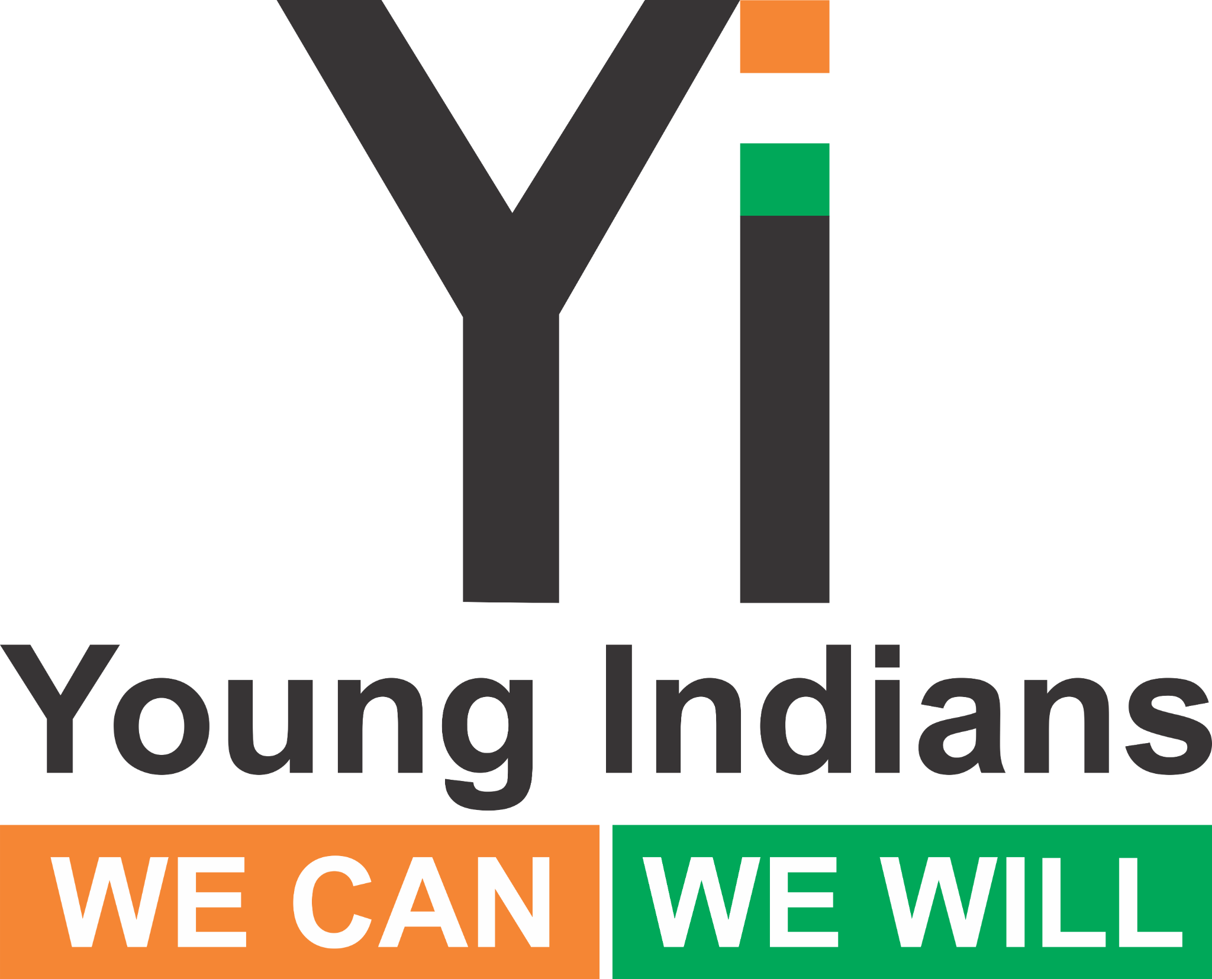 | Strong Minds, Open Doors — Health Round Table  Chapter Prompt Bank & Handout Kit

Why this programme (and why now)
• Youth health and dignity shape learning, livelihoods, and lifelong wellbeing.
• Stigma, misinformation, and infrastructure gaps keep many from seeking help or staying healthy.
• These Round Tables turn youth insight into local action and a national policy voice at the Yi Summit.
How chapters should use this kit
1) Pick **ONE or TWO** topics (max) that fit your local context.
2) From the prompt bank, choose 6–10 prompts that will work best for your room.
3) Print the **Participant Handout Seeds** for only those topics you’ve chosen.
4) Timebox: 45 minutes total for Health (see mini-agendas below). Keep notes visible on a board.
5) Close with **two concrete commitments** (who/what/when) and capture them in your report.
6) Add **Fireflies AI (fred@fireflies.ai)** to record + minute. Forward link/PDF within 24 hours.
Mini-agendas (pick one)
30 min | Welcome 3’ • One topic 20’ • Commitments 5’ • Close 2’
45 min | Welcome 5’ • One topic 25’ • Second topic 10’ • Commitments 5’
60 min | Welcome 5’ • Two topics @20’ each • Commitments 10’ • Close 5’
Safeguarding & care
• This is a community dialogue, not therapy. Avoid personal medical advice.
• Share local helplines and school/college counsellor contacts.
• If someone discloses risk of harm, pause and follow local escalation protocols.

Topic A — Mental Health: Break the Stigma
• How do you define ‘mental health’ in your own words? What myths persist locally?
• What language (words/phrases) harms or helps? How can we shift it?
• What stops people from seeking help (cost, shame, time, confidentiality, parental consent)?
• Where do youth turn first—friends, family, teachers, internet—and what do they need from each?
• What does a supportive response look like when someone opens up? What should we avoid saying?
• How can schools create ‘safe corridors’—clubs, peer listeners, quiet rooms, open office hours?
• What role can parents play without policing—listening, routines, validation, boundaries?
• How are exams, social media, or sleep patterns affecting stress and mood?
• What local/online resources are actually trusted? What’s missing?
• What would ‘no wrong door’ support look like in your neighbourhood?
• If we could change ONE school rule to reduce stress, what would it be?

Topic B — Teen Resilience: Strong Mind, Strong World
• What does resilience mean to you (beyond ‘just tough it out’)?
• What’s the difference between coping and numbing? How do we know which we’re doing?
• Which daily habits most boost resilience (sleep, nutrition, movement, sunlight, social time)?
• Whose ‘failure story’ helped you most? How can we normalise setbacks?
• How do we build digital resilience—boundaries, muting, reporting, mindful scrolling?
• Who are the ‘resilience allies’ in your life—teacher, coach, sibling, friend, mentor?
• How can peer buddy systems work in your school/college? What training is needed?
• Which campus initiatives would help—peer mentors, resilience clubs, office hours, quiet spaces?
• How do we ensure girls, boys, and non-binary youth all feel included in supports?
• Write one ‘if–then’ plan for a common stress trigger (e.g., “If I panic before exams, then…”).

Topic C — Peer Pressure & Substances: Say No
• Where does pressure show up—classrooms, canteens, group chats, parties, online trends?
• What are the most common ‘asks’ (vaping, alcohol, pills)? What myths fuel them?
• What are polite but firm ways to refuse? Try script-building together (‘not today’, ‘I don’t’).
• How can friends back you up—ally signals, exit plans, code words?
• What personal triggers and high‑risk times/places do we each have?
• How do FOMO and status work in your circles? What’s the real cost of ‘fitting in’?
• What do school/college policies say? What would an ‘amnesty for help’ look like?
• How can teachers and parents talk without shaming? What questions open conversation?
• What positive alternatives can we amplify—sports, arts, volunteering, maker clubs?
• What would a ‘pressure-free zone/event’ look like in your chapter or campus?
• Design a “Yes to…” campaign (what are we saying YES to instead of substances?).
• Practice two role‑plays: 1) Refusal, 2) Supporting a friend who wants to refuse.

Topic D — Water, Hygiene & Dignity: Hygiene Heroes (WASH)
• What’s the current reality of toilets, handwashing points, soap/water availability?
• Where do hygiene gaps most harm dignity—privacy, safety, cleanliness?
• How do we tackle menstrual health stigma in a respectful, practical way?
• How accessible are facilities for students with disabilities (ramps, space, grab bars, height)?
• What low‑cost fixes are feasible this month (bins, signage, soap restock system)?
• Who will maintain them—student teams, janitors, PTAs, vendors? What’s the rota?
• What nudges work—posters, peer champions, ‘wash your hands’ anchor points?
• How should waste be handled/disposed of safely and sustainably?
• What partnerships help—municipal bodies, NGOs, CSR, local businesses?
• How can we check progress—simple audits, photo logs, student ‘WASH captains’?
• Create a one‑page WASH charter for your campus/community and post it visibly.

Participant Handout Seeds (print only for chosen topics)

Seed — Mental Health: Break the Stigma
• Why we’re here: talk safely, learn options, support each other.
• Prompts: stigma words; asking for help; what support looks like; one habit for 14 days.
Notes / Ideas: ________________________________ ________________________________
Commitment (one action before the Summit): _____________________________________

Seed — Teen Resilience: Strong Mind, Strong World
• Why we’re here: build skills and allies to bounce forward.
• Prompts: coping vs numbing; habits; ‘if–then’ plan; weekly ritual for your class/team.
Notes / Ideas: ________________________________ ________________________________
Commitment (one action before the Summit): _____________________________________

Seed — Peer Pressure & Substances: Say No
• Why we’re here: protect choice and dignity under pressure.
• Prompts: scripts to say no; ally plans; positive alternatives; pressure‑free events.
Notes / Ideas: ________________________________ ________________________________
Commitment (one action before the Summit): _____________________________________

Seed — Water, Hygiene & Dignity: Hygiene Heroes
• Why we’re here: turn small fixes into big dignity gains.
Notes / Ideas: ________________________________ ________________________________
Commitment (one action before the Summit): _____________________________________

What to submit after your session
• Top 5 insights from the chosen topic(s)
• Two concrete commitments (who/what/when)
• Fireflies AI transcript/minutes link + 1–2 photos
• Use the national reporting template by **28 Sept**

Thank you for powering Strong Minds, Open Doors. Your local actions inform the Yi National Health & Accessibility Summit.

