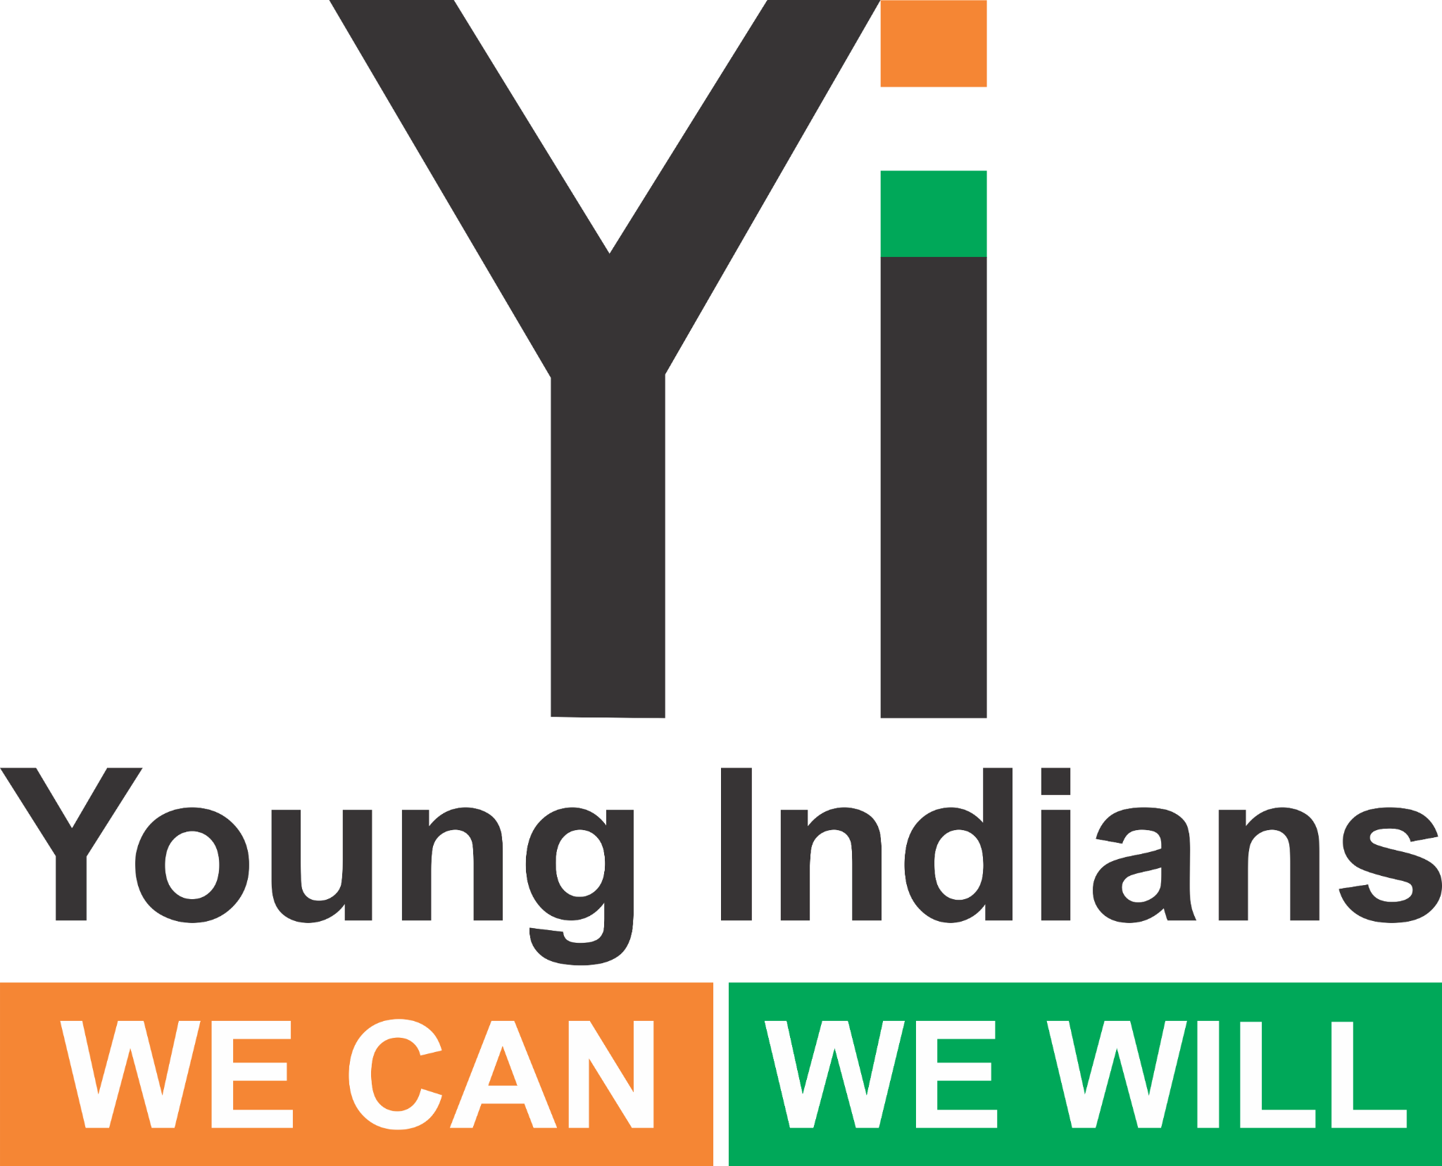 | Social Media Guide – Yi Health & Accessibility Round Tables

Hashtags & Handles
#YiHealth2025 #EnableAccess2025
@youngindians.yi @yionline @yitweets

What to Post
- Pre: Save-the-date, agenda, invites.
- Live: Photos & quotes.
- Post: Key takeaways + group photo.

Sample Captions
“Accessibility is for Everyone… #YiHealth2025 #EnableAccess2025”

Visuals
Use provided WhatsApp image and deck cover. Keep logos visible.

