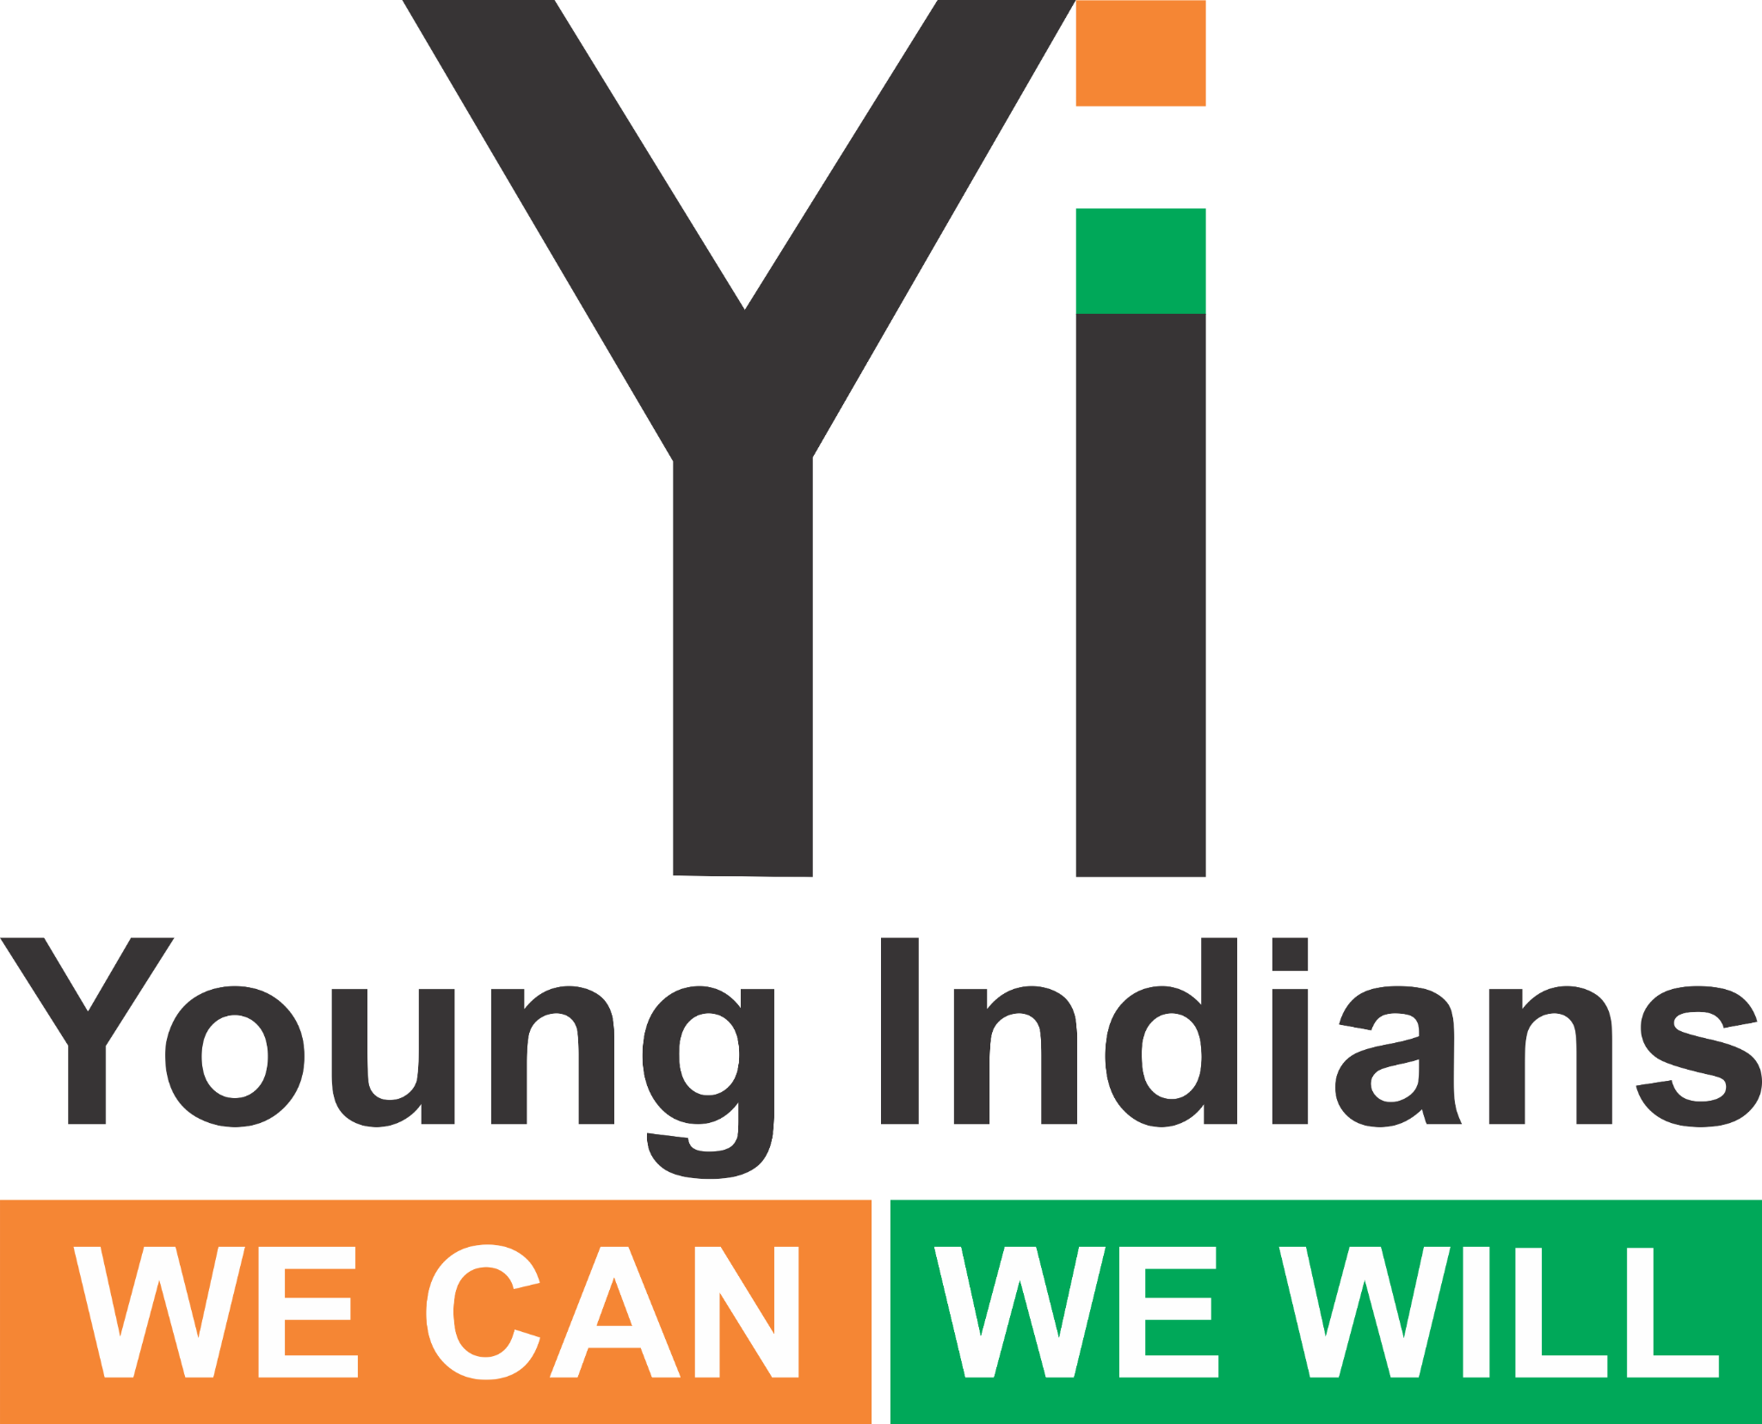 | Yi Chapter-Level Round Table Toolkit  Health & Accessibility September 2025

Strong Minds, Open Doors
Youth Action for Health, Hygiene & Accessibility

Purpose & Objectives
- Ignite honest, inclusive, action-oriented dialogue on youth health and accessibility across India.
- Capture grassroots insights to feed into the Yi National Health & Accessibility Summit (late Sep / early Oct).
- Build momentum for policy advocacy, local initiatives, and national visibility.

Format Overview (2 Hours)
0:00–0:10 Welcome & Opening
0:10–0:15 Short video / context setting
0:15–1:00 Part 1 – Strong Minds (Health Round Table)
1:00–1:45 Part 2 – Open Doors (Accessibility Round Table)
1:45–2:00 Closing reflections & group photo

Recommended Participants
- Yi members; youth (teens & college students); parents; educators/school reps
- Local health experts & mental health counsellors; NGOs
- Persons with Disabilities (PwDs); disability advocates; accessibility & civic officials

Part 1 – Strong Minds (Health): Discussion Modules & Prompts
- Mental Health – Break the Stigma
• Why do we hesitate to talk about stress/anxiety/depression?
• What emotional support works locally?
- Teen Resilience – Strong Mind, Strong World
• What are teens struggling with today?
• How can peer groups/families build a safer mental environment?
- Peer Pressure & Substances – Say No
• What does peer pressure look like in schools/colleges?
• What would a supportive youth culture look like?
- Water, Hygiene & Dignity – Hygiene Heroes
• What taboos persist around menstrual hygiene/sanitation?
• What low-cost improvements are most urgent at school/community?

Part 2 – Open Doors (Accessibility): Discussion Modules & Prompts
- Physical Access – More than Ramps
• Which spaces remain inaccessible? Who ensures compliance?
- Inclusive Education & Workplaces
• Do schools/offices accommodate different needs? Which reasonable accommodations help?
- Accessible Healthcare & Services
• Are clinics/hospitals accessible? How can technology bridge gaps?
- Attitudes & Awareness – Changing the Lens
• What biases exist? Why does accessibility benefit everyone?

Roles & Responsibilities
- Chapter Chair/Lead: Convene stakeholders; assign moderator & rapporteur; ensure Fireflies AI is added; confirm venue basics (step-free entry, seating space, mic).
- Moderator: Keep time; include diverse voices (youth & PwDs); drive clear action points.
- Rapporteur: Capture key takeaways per module; collect photos; submit report by 28 Sept.

Submission & Visibility
- Submit 1-page report + Fireflies AI link/PDF within 24 hours; final deadline 28 Sept.
- Social: #StrongMindsOpenDoors #YiHealth2025 #EnableAccess2025
Tag: @youngindians.yi @yionline @yitweets

